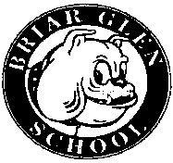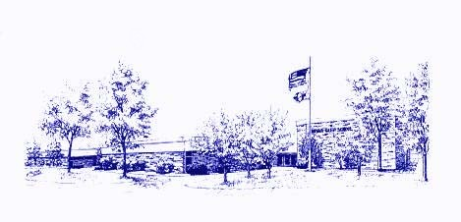
Minutes of the Briar Glen
PTC Meeting
October 20, 2022

Call to Order: Co-Presidents Meghan Menconi and Billy Cruz called the meeting to order at
7:00 pm.

Attendees: Meghan Menconi (Co-President), Billy Cruz (Co-President), Eric Sedlak (Treasurer), Suzanne Kimmerly (Secretary), Mitch Dubinsky, Brianna Garcia (teacher), Bob Alexander, Jessica McGee, Letty Lilly, Nicole Lenocker, Monica Gomez, Kimbery Lorvig, Dana Early, Rachel Butryn, Jenny Schubert, Joanna Inserra (Vanecek)

Treasurer’s Report: Bank Accounts 09/15/22 through 10/19/22
Totals for all accounts: $24,225.38, Checking $23,724.56, Savings $500.82
Notable Income: Bank Interest: $0.29, Boosterthon: $12,695.43, PTC Fees: $2,232.68, Monster Mash: $1,347.12, Rosati’s: $100

Expenses: PTC Operating Costs: $3,145.00

Principal’s Report: McTeacher’s Night on October 25th from 4:00-7:00. Lockdown Drill will be October 24th. On October 7th, the Glen Ellyn and DuPage Sherriff Department came out to speak with and train the staff on Run, Hide, Fight. Run, Hide, Fight gives kids and teacher options versus staying in one place. Teachers make the best choice in the moment. Briar Glen is now a “grief sensitive” school thought the New York Life Grief Sensitive Schools Initiative. ocial work intern who helped with this. Prior to Covid 1 in 15 students suffered some sort of grief or loss. Post Covid, it is 1 in 13. About 12 teachers participated in the training thanks to a $500 grant that was received. There will be kits available for kids who may have suffered a loss, with something as simple as a stuffed animal or book. Briar Glen had the student spotlight at the board meeting last Monday showcasing 5th graders with their engineering design process and their catapult creation.

Teacher’s Report: Thank you for the Fun Run. It was a big hit. Delivering the prizes to our room was helpful and less overwhelming than in years past. The Treat Cart was wonderful.

President’s Report: Open discussion with Dr. Tammaru this month about what all of the elementary schools’ PTC events are coming up. Dr. Tammaru and Board Member Donna Kemp will be here for the November 10th meeting.

Boosterthon: Huge success. We met our goal. Our estimated profit is a little over $28,000. Thank you to all of the families and friends who donated and supported.

Treat Cart: The next one will be December 15th. Every teacher will get a container and choose from an array of homemade holiday treats.

Monster Mash: 370 people are preregistered. With a total from MySchoolBucks and entry forms of $2,500, photo booth, DJ, and popcorn will be deducted and looking at a profit of about $800. Monica’s last year and Letty will be doing it for one more year and then will be passing it on to someone new. Prizes for kids are Kimmers Ice Cream gift cards and 3 family prizes are $25 to 302 Wheaton.

Benefit Days: Received $670 from Evereve in September. Received $44 from Oberweis. McTeacher is October 25th. Rosati’s is once a month. Dana Early is working on a full-day Panera benefit day.

Class Parties: Volunteers should have heard from the head parent and boxes are being made for each class.

Movie Night: Information coming soon regarding the movie that will be shown for K-2 on November 4th and 3-5 will be on November 11th.

Bookfair: Sign-up Genius went out for parent volunteers. Profit will be in cash and books for this year.

Winter Plant Sale: Order forms are due October 24th. We are using the same company from the Spring Flower sale where we earned a large profit.

Miscellaneous: Middle School principal is retiring at the end of this year. Hoping to seek information as to what parents of future middle schoolers would want in a principal.

Next PTC Meeting: November 10th, 2022 at 7:00 pm

Respectfully submitted,
Suzanne Kimmerly

