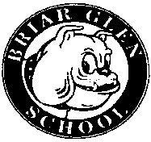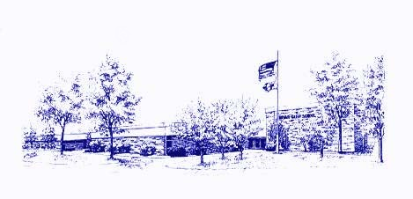
Minutes of the Briar Glen
PTC Meeting
November 10, 2022

Call to Order: Co-Presidents Meghan Menconi and Billy Cruz called the meeting to order at
7:00 pm.

Attendees: Meghan Menconi (Co-President), Billy Cruz (Co-President), Eric Sedlak (Treasurer), Suzanne Kimmerly (Secretary), Mitch Dubinsky, Dr. Emily Tammaru (Superintendent), Donna Kemp (School Board Member), Brianna Garcia (Teacher), Nicole Lenocker, Claire Cruz, Jessica McGee, Wendy Pawelski

Treasurer’s Report: Bank Accounts 10/20/22 through 11/9/22
Totals for all accounts: $60,873.64, Checking $60,372.80, Savings $500.84
Notable Income: Bank Interest: $1.20, Boosterthon: $31,667.71, PTC Fees: $73.52, Monster Mash: $2,169.00, Dine-Out Nights and Evereve: $1,866.50, Spirit Wear $165.00, Plant Sale: $1,850.00, Donations: $98.97, Movie Night: $237.21

Expenses: Class Parties: $194.30

Superintendent’s Report: Community supported with 72% approval for the bond referendum. Briar Glen’s office and entrance will be updated this summer. The new entrance will be etched out from the vestibule. Other buildings will have HVAC updated. Briar Glen’s HVAC will be done the following summer. Summer School will take place at Briar Glen this summer due to construction at other elementary schools. It will be 4 weeks, Monday through Thursday. December 1st will be the first community conversation at noon and 6:00pm on Social-Emotional Learning and open questioning afterwards. Another one will be hosted in February. At this month’s board meeting, auditors will come and report a clean audit and the tax levy will be presented. District 89’s school board was recognized by the Illinois Association of School Boards for excellence and governance. There are over 840 school districts in the state of Illinois and District 89 was one of 30 school districts were recognized.

Principal’s Report: Another successful Team Day occurred last month. Next Team Day is November 22. Student Ambassadors are helping to plan. The former “Buster Bones” will now become Pawsitive Paws. This will being back school-wide celebrations and shout outs to the positive things going on in the school that students are doing. McTeacher’s Night was great.

Teacher’s Report: McTeacher Night was awesome. Heard great things about the Monster Mash from staff and students. Class Party kits were helpful. They took the pressure off of teachers and gave a sense of relief knowing that grade levels were all doing the same thing.

President’s Report: Nothing to report due to Dr. Tammaru’s

Treat Cart: December 15th will be the next treat cart. Sign-up will go out after Thanksgiving.

Monster Mash: Had a great turnout. There were over 600 people in attendance. Well over 250 tickets were sold at the door.

Benefit Days: December 7th from 4:00-8:00 will be at Panera.

Class Parties: Classroom parties went well. An email from the head classroom parent with instructions on the items in the classroom box would be helpful to the volunteers.

Movie Night: 50 K-2 graders attended. Grades 3-5 Movie Night will be Friday.

Bookfair: Set-up is Wednesday and will run Thursday from the start to school until 8:00pm. Friday during school and Monday from the start of school until 8:00pm.

Winter Plant Sale: Plants will come in early December. Profit was about $600.

Miscellaneous: Opinion on Parent’s Night Out was discussed regarding preferences for informal versus formal gatherings.

Next PTC Meeting: January 19th, 2022 at 7:00 pm

Respectfully submitted,
Suzanne Kimmerly

