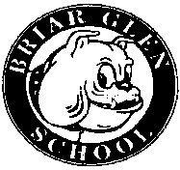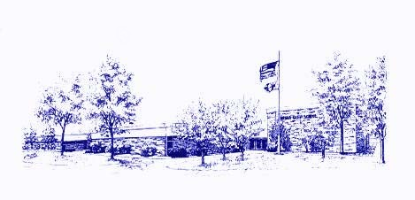
Minutes of the Briar Glen
PTC Meeting
March 16, 2023

Call to Order: Co-Presidents Meghan Menconi and Billy Cruz called the meeting to order at
7:00 pm.

Attendees: Meghan Menconi (Co-President), Billy Cruz (Co-President), Suzanne Kimmerly (Secretary), Mitch Dubinsky, Christyn Esposity, Lyndi Bowers, Nicole Lenocker, Bob Alexander, Lee Cuculich, Dana Early, Jen Schubert

Treasurer’s Report: Bank Accounts 2/013/23 through 3/15/23
Totals for all accounts: $24,484.71, Checking $23,983.79, Savings $500.92
Notable Income: Bank Interest: $0.85, Daddy-Daughter Dance: $2,895.00, Amazon Smile: $103.08, PTC Fees: $63.98

Expenses: Class Parties: $789.52, One Book One School: $800.00, Cheerleading: $74.90

President’s Report: There are two vacancies for the PTC board for next year: co-president and treasurer. If interested, please contact the board. We will nominate in April and vote in May.

Principal’s Report: Looking to replace/fix the bridge on the primary playground. IAR is occurring this week and everything is going well. One School One Book will begin in April. Each family will receive one book. There will be various activities occurring in relation to the book. There will be some staffing changes for next year. Emily Waghorne will be moving from 4th grade to 2nd grade, Emily Strauk will now be a full time psychologist at Briar Glen, and a third section of 5th grade will be added.

Teacher’s Report: (none)

Daddy-Daughter Dance: The dance was very well attended (over 300 people) and the kids had a wonderful time. $1,200 was raised from the raffle.

Trivia Night: April 14th at Warren’s Ale House. There are only 5 spots left.

Plant Sale: Forms are due Monday, April 3rd.

Treat Cart: Monday, May 1st is the next scheduled Treat Cart. It will be a rolling pizza/soda cart.

School Supply Kits: A service that is provided to parents to purchase school supplies online for your child. When you come for Meet the Teacher in the fall, the supplies will be on your child’s desk. The company we are going through is First Day School Supplies. There will be an option to add headphones if you’d like, with other options to purchase Under Armour or Vera Bradley backpacks.

Bulldog Run: Will be Sunday, May 21. The race will begin at 1:00, but we ask that runners and walkers be here by 12:30. An Ice Cream Truck has been reserved and we are in contact with Burritoville from last year, as well as Golden Eagle Hot Dogs. We plan to have two bouncy houses this year due to it being a big hit last year.

Cheerleading: Very successful this year. We had 46 students. They performed their final dance/cheer at Glen Crest and had a party afterschool for their last practice.

Miscellaneous: Teacher Appreciation will be May 8th through May 12th.

Next PTC Meeting: April 20th, 2023 at 7:00 pm

Respectfully submitted,
Suzanne Kimmerly

