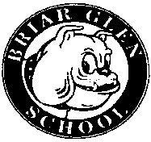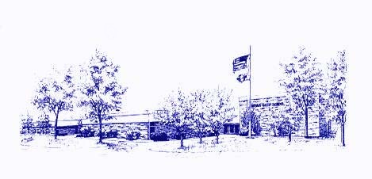
Minutes of the Briar Glen
PTC Meeting
April 20, 2023

Call to Order: Co-Presidents Meghan Menconi and Billy Cruz called the meeting to order at
7:00 pm.

Attendees: Meghan Menconi (Co-President), Billy Cruz (Co-President), Suzanne Kimmerly (Secretary), Mitch Dubinsky, Rachel Butryn, Bob Alexander, Amber Norman, Megan Jakobsze, Lyndi Bowers, Nicole Lenocker, Lee Cuculich

Treasurer’s Report: Bank Accounts 3/13/23 through 4/15/23
Totals for all accounts: $26,341.20, Checking $25,840.26, Savings $500.94
Notable Income: Bank Interest: $1.03, Plant Sale: $617.75, Bulldog Run: $70.75, Candy Gram/5th Grade Fling: $1,487.75, Misc. Donations: $156.61, PTC Fees: $9.14

Expenses: (none)

President’s Report: Our new Superintendent, Dr. Eccarius starts on July 1st. There is a reception welcoming him on Tuesday, April 26th at 6:00 at the District Office. There is a principal opening at Westfield Elementary School. Briar Glen needs a 5th grade parent volunteer for the Amazing Race to introduce the 5th grade students to Glen Crest.

Principal’s Report: Kindergarten Night is April 26th at 6:00. All parents with in-coming kindergartners are welcome to attend. Our last Team Day of the year is April 21. SEL Ambassadors suggested an Earth Day theme for Team Day. Too Good for Drugs graduation for 5th grader will be May 18th at 2:15. Field Day is May 19th. Summer construction will begin on May 26th. The front office will be the focus of the construction. MAP testing begins May 1st until May 12th, including make-ups. There will be three sections of kindergarten for the 2023-2024 school year due to enrollment. Therefore, Annie Lillwitz will be teaching kindergarten. This leaves two 4th grade openings, one 5th grade opening, one 2nd grade opening, and music.

Teacher’s Report: Staff members who attended Trivia Night had a lot of fun and appreciated being able to participate

Trivia Night: We had 11 teams total (9 parent teams and 2 teacher/principal teams). We are hoping to have this event again next year thanks to the positive response.

Plant Sale: Orders were due April 4th. We made about $700.00.

Treat Cart: Final Treat Cart will be Monday, May 1st.

School Supply Kits: 25 orders have been made thus far. School Supply Kits will be on your students’ desk for the Meet the Teacher event in the fall.

Bulldog Run: Food trucks that were reserved originally have backed out. We now will have Go, Doggy Run, who will have hamburgers, hot dogs, and walking tacos. We will also have an ice cream truck, and looking into having an Italian food truck. We will have two bouncy houses: obstacle course and castle for younger kids. T-shirts are designed and ready to be ordered with registration is complete. We received a $100 donation from Jewel in Wheaton to be used for granola bars for runners after the race.

5th Grade Fling: Many parents have already signed up to volunteer. They are working to decide on a 5th grade gift and determining questions for the scavenger hunt.

Field Day: Field Day will be on May 19th. Lisa O’Brill will be in charge and Lee Cuculich will be shadowing to take over the event next year.

Teacher Appreciation: Teacher Appreciation will be May 1st-5th. Claire Cruz and Erin Postovalov will be organizing.

Nominations: Amber Norman was nominated for the PTC position of treasure by Nicole Lenoker and seconded by Megan Jakonsze. Lyndi Bowers was nominated for the PTC position of co-president by Lee Cuculich and seconded by Bob Alexander.

Miscellaneous: Looking forward to the fall Fun Run that will take place on October 13th, Rachel Butryn suggested we start considering what the funds should go towards. We will look for suggestions from parents and staff. October 3rd will be the kickoff for the event. Co-chairs are looking for more volunteers to help co-chair the event in the future. The parts for the bridge repair on the primary playground are 4 weeks from coming in.

Next PTC Meeting: May 18th, 2023 at 7:00 pm

Respectfully submitted,
Suzanne Kimmerly

